# Name: Heshika Pokala

# Data: 30-10-24

# BERT-Based Sentiment Classification Model Documentation

## Overview

This document outlines the structure, functionality, and usage of a BERT-based sentiment classification model developed for predicting the sentiment of text inputs. The model utilizes the BERT architecture, specifically fine-tuned for binary sentiment classification (Positive or Negative). This comprehensive system is designed to handle both individual text inputs and batch processing from CSV files, generating reliable sentiment predictions while maintaining thorough logging of processed data.

**Key Features**

* **Binary Sentiment Classification**: Classifies input text into Positive or Negative categories.
* **Flexible Input Handling**: Accepts single reviews or batch processing from CSV files.
* **Embedding Generation**: Produces embeddings for each review, which can be useful for future analysis.
* **CSV Logging**: Systematically logs processed inputs and predictions for traceability.

**Model Architecture**

The model is built upon the BERT (Bidirectional Encoder Representations from Transformers) architecture, which excels in understanding the context of words in a sentence due to its deep bidirectional approach. The following key components are utilized:

* **Pre-trained BERT Model**: The model employs **BertForSequenceClassification**, allowing it to leverage the power of transfer learning for sentiment classification tasks.
* **Tokenizer**: Utilizes **BertTokenizer** to preprocess and tokenize input text into a format compatible with the BERT model.

### **Data Collection**

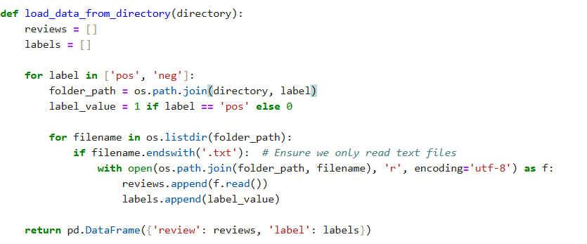

I utilized the **IMDB Large Movie Dataset** provided by Stanford for our project, specifically leveraging a training set of **25,000 samples**. This dataset comprises positive and negative movie reviews, making it ideal for training our sentiment classification model. The code snippet illustrates how we load these reviews by reading text files from directories designated for positive and negative sentiments, assigning the appropriate labels to each review.

1. **Data Cleaning**

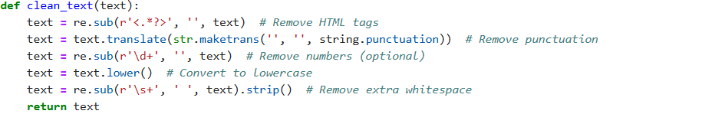

The data cleaning code is designed to preprocess text data effectively, ensuring that it is in a suitable format for analysis or modeling in natural language processing (NLP) tasks.

### **Model Initialization**

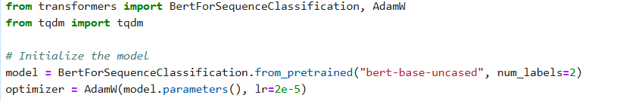

Initializes the model with two output labels, corresponding to Positive and Negative sentiments, and loads the tokenizer for text preprocessing.

* **Tokenization**: Input text is tokenized and converted into tensor format.
* **Model Inference**: The model produces logits (raw prediction scores), which are processed to determine the predicted sentiment class.
* **Output**: Returns 0 for Negative and 1 for Positive sentiment.

.

1. **Tokenization**

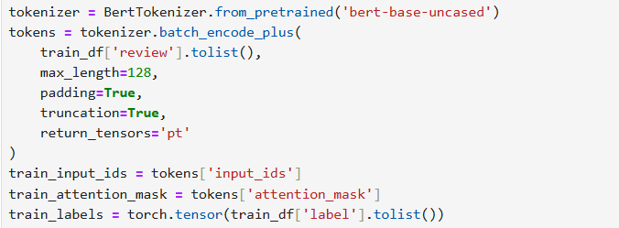

The reviews are tokenized, padded, and truncated to fit the input size required by BERT. This results in input_ids and attention_masks, which are then converted into tensor format along with the labels.

1. **Batch Processing**

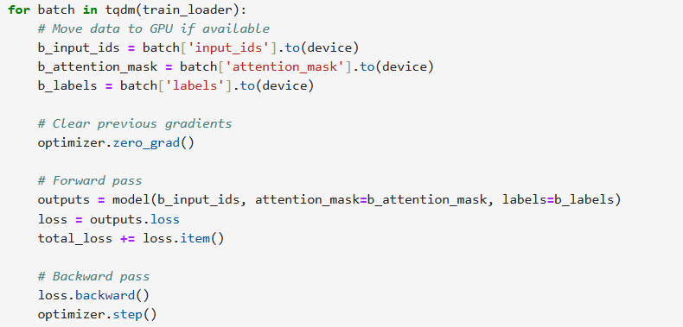

For each batch in the train_loader, the input data and labels are moved to the designated device. The model performs a forward pass, calculates the loss, and performs a backward pass to update the model weights. After all batches are processed, the average training loss for that epoch is computed and printed.

1. **Model and Tokenizer Saving**

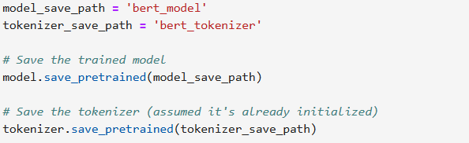

After training is complete, the model and tokenizer are saved to specified paths for later use, allowing for easy deployment and inference.

**Training Model Documentation: Continuous Training and Deployment Pipeline**

The continuous retraining and deployment pipeline is designed to maintain and enhance the performance of a sentiment analysis model over time. As new user data is ingested, the pipeline ensures that the model adapts to changing patterns and trends in sentiment expression.

## ****Pipeline Components and Workflow****

### **1. Data Ingestion and Preprocessing**

* The pipeline accepts both individual text inputs and batches (CSV files) to accommodate various deployment settings (real-time vs. batch processing).
* **Process**:
  + **Text Input**: Single texts are tokenized and passed directly to the model for real-time inference.
  + **CSV Input**: CSV files are processed row-by-row, generating predictions and logging the data in structured output for further analysis and retraining.

### **2. Tokenization and Embedding Generation**

* The pipeline uses BERT’s tokenization process to convert textual data into embeddings that the model can understand.
* **Process**:
  + **Tokenization**: Each text entry is tokenized using BERT’s pretrained tokenizer, converting text into tokens with special markers like [CLS] and [SEP].
  + **Embedding Generation**: Tokenized inputs are then transformed into embeddings, enabling the model to grasp the contextual sentiment in each text.
* Consistent and effective tokenization ensures that the model receives a compatible input format, essential for accurate inference and drift detection.

### **3. Data Drift Detection**

* **Purpose**: Monitor for significant changes in input data distribution across training data and new data provided by the user, indicating when retraining may be necessary to maintain accuracy.
* **Process**:
  + **Wasserstein Distance Calculation**: The pipeline compares recent data embeddings with past data distributions using the Wasserstein Distance metric, a reliable way to measure distributional changes.
  + **Drift Threshold**: A threshold value is set to trigger retraining if the drift score exceeds this level multiple times consecutively, reducing retraining due to temporary changes.
* Data drift detection ensures that the model adapts only when necessary, reducing computational cost while maintaining high accuracy over time.

### **4. Confidence-Based Prediction Filtering**

The model employs confidence scoring to quantify the certainty of its predictions, ensuring that only high-confidence predictions are logged or utilized for retraining. This helps in maintaining data quality and improving the robustness of the sentiment analysis pipeline.

**Process**:

1. **Confidence Score Calculation**: For each prediction made by the model, a confidence score is computed. This score represents the model's certainty about its predicted class (Positive or Negative).
2. **Threshold Setting**: A confidence threshold is established (e.g., **0.8**). Predictions that yield a confidence score below this threshold are filtered out, preventing unreliable or noisy inputs from being logged or used for retraining.
3. **Usage in Data Drift Detection**: When data drift is detected (i.e., significant changes in input data patterns), confidence scores become crucial. The model uses these scores to assess and label unseen data accurately, ensuring that only predictions with a high level of certainty contribute to the retraining process.

**Benefit**: By implementing confidence scoring and setting a threshold, the pipeline enhances the accuracy of sentiment representation, leading to higher-quality data for retraining and drift assessment. This approach minimizes the risk of incorporating erroneous predictions, ultimately improving the overall performance and reliability of the sentiment classification model.

### **5. Automated Retraining Trigger**

* Automatically initiate retraining when certain conditions are met, ensuring the model stays up-to-date with the latest data trends.
* **Process**:
  + The model retraining is triggered based on consecutive drift alerts or prolonged low prediction accuracy.
  + **Accuracy-Based Retraining**: In addition to drift, the model retrains if accuracy falls below a threshold for consecutive assessments.
* **Benefit**: This automation makes the model self-sustaining by reducing manual oversight, helping the pipeline maintain optimal performance under changing data conditions.

### 6. **Retraining Workflow and Model Versioning**

* Efficiently retrain, validate, and save new model versions to keep performance consistent without manual intervention.
* **Process**:
  + The retraining process fine-tunes the BERT model on accumulated recent high-confidence data.
  + Each model version is stored in a separate folder, along with its corresponding tokenizer and other configuration files.
* **Benefit**: Model versioning enables easy rollback to previous versions if necessary and maintains consistency in the deployment environment.

### **7. Output and Storage**

* **Purpose**: Log results and store outputs in accessible formats for further analysis and monitoring.
* **Process**:
  + **CSV Logging**: Batch predictions, confidence scores, and other metadata are logged in CSV files, which are available for download and analysis.
  + **Embedding and Drift Scores**: These are stored for comparison in future drift detection processes.
* **Benefit**: By storing outputs in standard formats, the pipeline makes results readily accessible and compatible with analytics tools, facilitating continuous improvement.

### **8. Deployment**

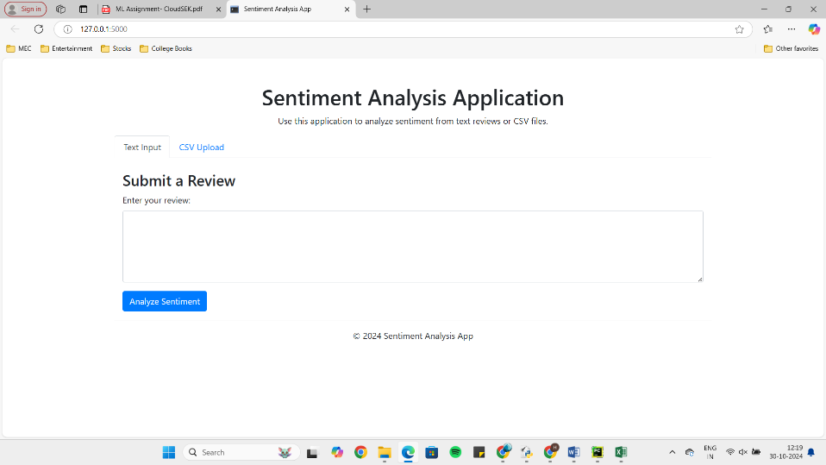

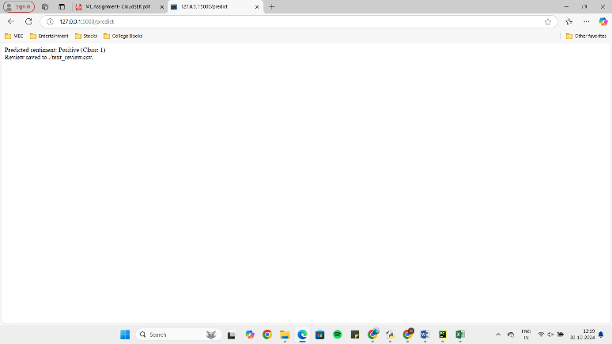

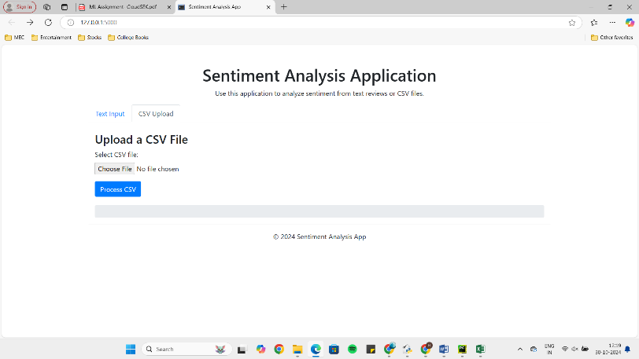

In this project, we utilized HTML for the user interface, allowing users to easily upload CSV files and input text for predictions. The backend integrates a transformer-based text classification model (Please refer to RETRAINING THE MODEL Code), specifically designed to predict sentiments in text data. This system not only provides immediate predictions but also supports continuous retraining of the model. When the model's performance becomes stale or degrades over time, it can be retrained with new data to ensure optimal accuracy and relevance in its predictions. This adaptive approach enhances the model's robustness and maintains its effectiveness in a dynamic environment.

## ****Inference: Real-Time and Batch Modes****

The pipeline is adaptable for both **real-time and batch inference**.

* **Real-Time Inference**: Single inputs are tokenized and classified immediately, suitable for applications where instant feedback is required.
* **Batch Inference**: CSV files with multiple inputs are processed simultaneously, with results saved in an output CSV file.

This dual-mode functionality ensures compatibility with various application settings, from real-time chatbots to large-scale sentiment analysis in datasets.

## ****Key Features and Optimizations****

1. **Dynamic Retraining**: The pipeline’s retraining is triggered only after several consecutive drift or accuracy alerts, saving costs by avoiding frequent unnecessary retraining.
2. **Confidence-Based Predictions**: Only high-confidence predictions are logged, ensuring quality input for drift monitoring and retraining.
3. **Scalable Design**: The architecture can be adapted to run on cloud or local environments, depending on the cost and performance needs.
4. **Cost-Effective Batch Processing**: Batch processing in CSV files reduces API and compute overhead, optimizing costs, especially in cloud deployments.

## ****Conclusion****

This continuous training and deployment pipeline is robust, reliable, and designed to ensure consistent model performance. The BERT-based model’s automated retraining, drift detection, and versioning mechanisms help keep it adaptive to new data patterns with minimal human intervention, making it suitable for real-world deployment in dynamic sentiment analysis environments.